

CS3343 Software Engineering Practice
Bug Report (Group 5)
Project Title: Sport Facility and Equipment Booking System

Name | Student Number
NG Ka Hung | 58533046
LIN Weiyuan | 58537684
LAU Wing Him | 58537137
IP Wing Kai | 58120400
LEE Kin Wai | 57925345
Chan Sing To | 58533974

Table of Content
Bug Report - #001 3
Bug Report - #002 5
Bug Report - #003 7
Bug Report - #004 9
Bug Report - #005 11
Bug Report - #006 13
Bug Report - #007 14
Bug Report - #008 15
Bug Report - #009 16
Bug Report - #010 17

Bug Report - #001
ID number | #001 | Severity | High
Name | Immediate terminate after catch an exception in Book Facility Page
Reporter | NG Ka Hung | Assigned to | LEE Kin Wai
Operation System | Windows 11 | Environment | Java SE 21
Status | Done | Version | v2.0
Submit Date | 13/11/2025
Last Edit Date | 23/11/2025

Description
It is a major functional issue in the Book Facility Page. When the user input an unexpected input for some fields, such as select facility. The program will throw an exception and crash immediately.
Steps to reproduce
> Login
> Select “1” in Home page
> input data with incorrect format or type
> an exception throw out and crash immediately
Expected result
The program should keep asking repeatedly until the user inputs a valid input, and allow the user to input “0” to escape the loop.
Actual result
Exception throwed and crashed immediately.

Notes (if applicable)
======= Login Page =======
Please enter your username: admin
Please enter your password: password123
Login successfully! Now jump to Home Page.

======= Home Page =======
1. Sport Facility Booking
2. Sport Equipment Booking
3. View Pending Booking
4. View Booking Record
L. Logout
E. Exit
========================
Please input function number (1-5), Logout (L) or Exit (E): 1

User admin is booking facility.
================ Available Sport Facilities =================
|| No. || Facility Name || Type ||
=============================================================
|| 1 || SF-001 || Basketball ||
|| 2 || SF-002 || Badminton ||
|| 3 || SF-003 || TableTennis ||
=============================================================
Select the facility to book (Enter the number): 4
Exception in thread "main" java.lang.IndexOutOfBoundsException: Index 3 out of bounds for length 3
at java.base/jdk.internal.util.Preconditions.outOfBounds(Preconditions.java:100)
at java.base/jdk.internal.util.Preconditions.outOfBoundsCheckIndex(Preconditions.java:106)
at java.base/jdk.internal.util.Preconditions.checkIndex(Preconditions.java:302)
at java.base/java.util.Objects.checkIndex(Objects.java:385)
at java.base/java.util.ArrayList.get(ArrayList.java:427)
at sportapp.ui.FacilityBookingUI.display(FacilityBookingUI.java:49)
at sportapp.SportApp.run(SportApp.java:67)
at sportapp.Main.main(Main.java:39)

Bug Report - #002
ID number | #002 | Severity | Medium
Name | View Current Record does not redirect to home page when no records
Reporter | LIN Weiyuan | Assigned to | LEE Kin Wai
Operation System | Windows 11 | Environment | Java SE 21
Status | Done | Version | v2.0
Submit Date | 15/11/2025
Last Edit Date | 23/11/2025

Description
When there are no available records to show in view current booking page, the view current booking page will not go back to home page automatically.
Steps to reproduce
> Login
> Select “3” in Home Page,
> and enter View Current Booking Page
Expected result
The program should display the line “No current booking found.”, and redirect back to the Home page automatically.
Actual result
“No current booking found.” and Option menu of view current booking page have shown.

Notes (if applicable)
======= Login Page =======
Please enter your username: admin
Please enter your password: password123
Login successfully! Now jump to Home Page.

======= Home Page =======
1. Sport Facility Booking
2. Sport Equipment Booking
3. View Pending Booking
4. View Booking Record
L. Logout
E. Exit
========================
Please input function number (1-5), Logout (L) or Exit (E): 3

No current booking found.

Booking Options:
1. Update date and time
2. Update facility
3. Cancel booking
4. Proceed to payment
5. Return to main menu
Please select an option (1-5): 5
======= Home Page =======
1. Sport Facility Booking
2. Sport Equipment Booking
3. View Pending Booking
4. View Booking Record
L. Logout
E. Exit
========================
Please input function number (1-5), Logout (L) or Exit (E):

Bug Report - #003
ID number | #003 | Severity | High
Name | Confirmed records still in pending status after payment
Reporter | LEE Kin Wai | Assigned to | Weiyuan LIN
Operation System | Windows 11 | Environment | Java SE 21
Status | Done | Version | v2.0
Submit Date | 16/11/2025
Last Edit Date | 22/11/2025

Description
When the user confirmed and finished the payment process, all pending records could not switch to “Confirmed” status. The expected result should be all pending records are changed to “Confirmed” status.
Steps to reproduce
> Login
> Select “3” in Home Page,
> and enter View Current Booking Page,
> input “4” to select Payment, and enter Payment page,
> input “1” to “confirm”, and select one of the payment method to finish payment
> redirect back to the Home page, and input “4” to enter View Current Booking Page again.
> the confirmed booking records are still in pending status.
Expected result
All pending records should switch to “Confirmed” status after payment.
Actual result
All confirmed records are still in “Pending” status after payment.
Notes (if applicable)
Screenshot 3.1
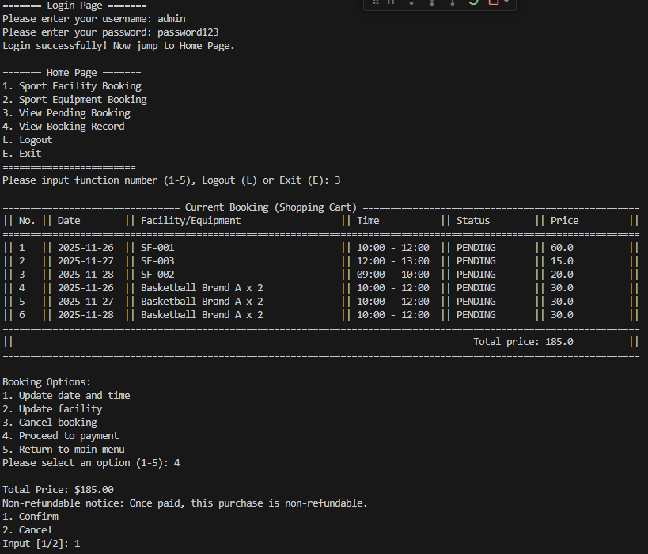
Screenshot 3.2
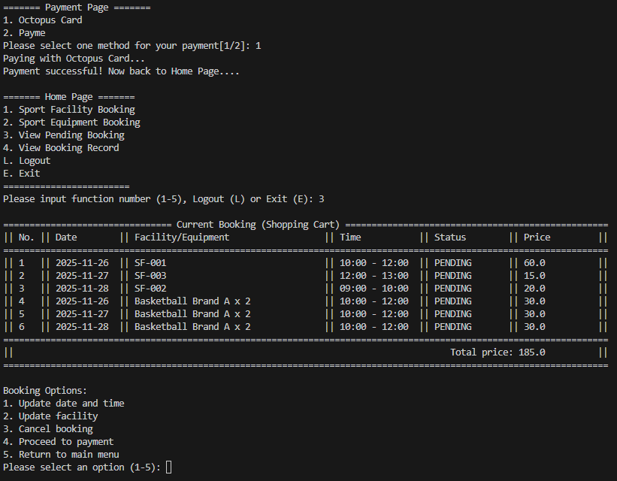

Bug Report - #004
ID number | #004 | Severity | High
Name | Infinite loop occurs when there are no available slots on the target date
Reporter | IP Wing Kai | Assigned to | LEE Kin Wai
Operation System | Windows 11 | Environment | Java SE 21
Status | Done | Version | v2.0
Submit Date | 20/11/2025
Last Edit Date | 24/11/2025

Description
When there are no available time slots for the target date, an infinite loop will occur. The ideal result should be repeatedly asking for input and making a quit option for the user to leave the prompting loop.
Steps to reproduce
> Login
> Select “1” in Home page
> Select a random facility, and make bookings for all available time slots,
> All time slots from 09:00 to 21:00 should be unavailable, and make a booking for that facility again.
> The infinite loop should occur as the program keeps asking the user for the start hour and end hour, since there are no single time slots available.
Expected result
The program should display the line “Sorry, there are no available slot for that day..”,
and ask the user for either the next booking or go back to the Home page.
Actual result
An infinite loop occurs as the program keeps asking the user for the start hour and end hour of the booking.
Notes (if applicable)
Which day do you want to book a SFT-002? e.g. 22/09/2025
27/11/2025
Available time slots on 2025-11-27 are:
1 . 11:00 - 21:00
Please input the start hour (e.g 09)
11
Please input the end hour (e.g 21)
21
User: admin
Booking confirmed for: SF-002
Date: 2025-11-27
Time: 11:00 - 21:00

Late return of facility will face penalty!

Do you want to book another facility/time slot? (y/n): y

User admin is booking facility.
================ Available Sport Facilities =================
|| No. || Facility Name || Type ||
=============================================================
|| 1 || SF-001 || Basketball ||
|| 2 || SF-002 || Badminton ||
|| 3 || SF-003 || TableTennis ||
=============================================================
Select the facility to book (Enter the number[1-3] or back home page[0]): 2
Which day do you want to book a SFT-002? e.g. 22/09/2025
27/11/2025
Available time slots on 2025-11-27 are:
Please input the start hour (e.g 09)
09
Please input the end hour (e.g 21)
10
Error: The requested time slot is not available. Please select a time from the list.
Please input the start hour (e.g 09)
13
Please input the end hour (e.g 21)
16
Error: The requested time slot is not available. Please select a time from the list.
Please input the start hour (e.g 09)

Bug Report - #005
ID number | #005 | Severity | Medium
Name | Invalid date allowed in Book Facility Page
Reporter | IP Wing Kai | Assigned to | LEE Kin Wai
Operation System | Windows 11 | Environment | Java SE 21
Status | Done | Version | v2.0
Submit Date | 20/11/2025
Last Edit Date | 24/11/2025

Description
When the user inputted an invalid date for the facility booking, the program still accepts the invalid date for the later booking process. For example, the date before today, the today’s date, etc.
Steps to reproduce
> Login
> Select “1” in Home Page,
> and enter Facility Booking Page
> start to make a booking
> input a invalid date
Expected result
The program should display the line “Invalid date. You can only make a booking for the day after today.”, and keep asking until the user provides a valid date.
Actual result
The invalid date is accepted by the program and allows the user to make a booking with the invalid date.

Notes (if applicable)
======= Login Page =======
Please enter your username: admin
Please enter your password: password123
Login successfully! Now jump to Home Page.

======= Home Page =======
1. Sport Facility Booking
2. Sport Equipment Booking
3. View Pending Booking
4. View Booking Record
L. Logout
E. Exit
========================
Please input function number (1-5), Logout (L) or Exit (E): 1

User admin is booking facility.
================ Available Sport Facilities =================
|| No. || Facility Name || Type ||
=============================================================
|| 1 || SF-001 || Basketball ||
|| 2 || SF-002 || Badminton ||
|| 3 || SF-003 || TableTennis ||
=============================================================
Select the facility to book (Enter the number[1-3] or back home page[0]): 1
Which day do you want to book a SFT-001? e.g. 22/09/2025
01/01/2024
Available time slots on 2024-01-01 are:
1 . 9:00 - 21:00
Please input the start hour (e.g 09)
09
Please input the end hour (e.g 21)
12
number of existing booking after 6
User: admin
Booking confirmed for: SF-001
Date: 2024-01-01
Time: 9:00 - 12:00

Late return of facility will face penalty!

Do you want to book another facility/time slot? (y/n):

Bug Report - #006
ID number | #006 | Severity | High
Name | Cart - Total price calculation throws IndexOutOfBoundsException
Reporter | Ivan | Assigned to
Operation System | Windows 11 | Environment | Java SE 21
Status | Done | Version | v2.0
Submit Date | 20/11/2025
Last Edit Date | 23/11/2025

Description
When viewing the current booking (shopping cart), the app throws IndexOutOfBoundsException while computing the total price for an equipment buying.
Steps to reproduce
> Register a new account.
> Rent a facility of your choice.
> Based on the facility, purchase the equipment you want from Sport Equipment Booking.
> Return to the home page.
> Check the cart (View Current Booking).
Expected result
The shopping cart displays successfully and the total price is computed safely
Actual result
The app crashes with:
Exception in thread "main" java.lang.IndexOutOfBoundsException: Index 1 out of bounds for length 1
(originating from EquipmentBookRecord.getTotalPrice()), interrupting the shopping cart display and payment flow.
Notes
======= Home Page =======
1. Sport Facility Booking
2. Sport Equipment Booking
3. View Pending Booking
4. View Booking Record
L. Logout
E. Exit
========================
Please input function number (1-5), Logout (L) or Exit (E): 3

================================ Current Booking (Shopping Cart) ==================================================
|| No. || Date || Facility/Equipment || Time || Status ||Price ||
===================================================================================================================
|| 1 || 2025-11-22 || SF-001 || 10:00 - 12:00 || PENDING || 60.0 ||
|| 2 || 2025-11-23 || SF-003 || 12:00 - 13:00 || PENDING || 15.0 ||
|| 3 || 2025-11-24 || SF-001 || 09:00 - 10:00 || PENDING || 30.0 ||
|| 4 || 2025-11-22 || Basketball Brand A x 1 || 10:00 - 12:00 || PENDING || 15.0 ||
|| 5 || 2025-11-23 || Basketball Brand A x 1 || 10:00 - 12:00 || PENDING || 15.0 ||
Exception in thread "main" java.lang.IndexOutOfBoundsException: Index 1 out of bounds for length 1
at java.base/jdk.internal.util.Preconditions.outOfBounds(Preconditions.java:100)
at java.base/jdk.internal.util.Preconditions.outOfBoundsCheckIndex(Preconditions.java:106)
at java.base/jdk.internal.util.Preconditions.checkIndex(Preconditions.java:302)
at java.base/java.util.Objects.checkIndex(Objects.java:365)
at java.base/java.util.ArrayList.get(ArrayList.java:428)
at sportapp.model.EquipmentBookRecord.getTotalPrice(EquipmentBookRecord.java:67)
at sportapp.ui.ViewCurrentBookingUI.displayCurrentBooking(ViewCurrentBookingUI.java:98)
at sportapp.ui.ViewCurrentBookingUI.display(ViewCurrentBookingUI.java:31)
at sportapp.SportApp.run(SportApp.java:73)
at sportapp.Main.main(Main.java:12)

Bug Report - #007
ID number | #007 | Severity | High
Name | Shopping cart displays global pending bookings (not filtered by user)
Reporter | Ivan | Assigned to
Operation System | Windows 11 | Environment | Java SE 21
Status | Done | Version | v2.0
Submit Date | 20/11/2025
Last Edit Date | 23/11/2025

Description
The controller method returns a global list of pending equipment bookings. The UI calls this unfiltered method when showing "current user" pending bookings, so a newly registered or logged-in user can see other users' pending records.
Steps to reproduce
>Register or log in as user A.
>Ensure there exists at least one pending equipment booking created by another user B.
>Open "View Current Booking"
>Observe the pending equipment booking list.
Expected result
The UI shows only pending equipment booking records that belong to the currently logged-in user (user A).
Actual result

The UI displays pending equipment booking records for all users (including records belonging to user B).

Bug Report - #008
ID number | #008 | Severity | High
Name | Infinite Loop in when update date and time in shopping cart
Reporter | Ivan | Assigned to
Operation System | Windows 11 | Environment | Java SE 21
Status | Done | Version | v2.0
Submit Date | 20/11/2025
Last Edit Date | 23/11/2025

Description
In the ViewCurrentBookingUI class, when there are no current bookings for the user, the function enters an infinite loop because the condition to exit the loop is never met. This happens when the user is prompted to make a choice, but the application does not handle the case where there are no bookings.
Steps to reproduce
>Run the application.
>Log in as a user with no current bookings.
>Navigate to the "View Current Booking" screen.
>Select 1. Update date and time
>Observe that the application enters an infinite loop.
Expected result
The application should inform the user that there are no current bookings and allow them to return to the main menu without entering an infinite loop.
Actual result
The application enters an infinite loop, continuously prompting the user for a choice without any valid options.
Notes
======= Home Page =======
1. Sport Facility Booking
2. Sport Equipment Booking
3. View Pending Booking
4. View Booking Record
L. Logout
E. Exit
========================
Please input function number (1-5), Logout (L) or Exit (E): 3

No current booking found.

Booking Options:
1. Update date and time
2. Update facility
3. Cancel booking
4. Proceed to payment
5. Return to main menu
Please select an option (1-5): 1
Select a booking (1-0): 1
Invalid selection. Please try again.
Select a booking (1-0): 1
Invalid selection. Please try again.

Bug Report - #009
ID number | #009 | Severity | Medium
Name | IllegalStateException thrown when updating date/time with no booking selected
Reporter | Ivan | Assigned to
Operation System | Windows 11 | Environment | Java SE 21
Status | Done | Version | v2.0
Submit Date | 20/11/2025
Last Edit Date | 23/11/2025

Description
File: ViewCurrentBookingUI.java
Location: method handleUpdateDateTime(), line containing: if (selection == null) throw new IllegalStateException("No booking selected.");
When the user triggers "Update date and time" but no booking is selected (selectBooking() returns null, e.g. no pending bookings or user cancels selection), the UI code throws an IllegalStateException instead of handling the situation gracefully. This results in an application crash or abrupt termination of the current flow.
Steps to reproduce
>Run the application.
>Log in as a user with no current bookings.
>Navigate to the "View Current Booking" screen.
>Select 1. Update date and time
>Observe that the application enters an infinite loop.
Expected result
The UI should display a friendly message (e.g. "No booking selected.") and return to the booking options/main menu. No uncaught exceptions should be thrown.

Actual result
An IllegalStateException("No booking selected.") is thrown at runtime, causing the program to crash or the UI flow to be interrupted.
Notes
======= Home Page =======
1. Sport Facility Booking
2. Sport Equipment Booking
3. View Pending Booking
4. View Booking Record
L. Logout
E. Exit
========================
Please input function number (1-5), Logout (L) or Exit (E): 3

No current booking found.
3. Cancel booking
4. Proceed to payment
5. Return to main menu
Please select an option (1-5): 1
No booking to select.
Exception in thread "main" java.lang.IllegalStateException: No booking selected.
at sportapp.ui.ViewCurrentBookingUI.handleUpdateDateTime(ViewCurrentBookingUI.java:168)
at sportapp.ui.ViewCurrentBookingUI.display(ViewCurrentBookingUI.java:40)
at sportapp.SportApp.run(SportApp.java:73)
at sportapp.Main.main(Main.java:12)

Bug Report - #010
ID number | #010 | Severity | Medium
Name | Invalid/time-conflict bookings when input the same hour in start time and end time
Reporter | Ivan | Assigned to | Weiyuan LIN
Operation System | Windows 11 | Environment | Java 21
Status | Done | Version | v3.0
Submit Date | 20/11/2025
Last Edit Date | 23/11/2025

Description
The UI will accept arbitrary integer hour inputs and create FacilityBookRecord objects with invalid or conflicting time ranges. This can produce zero-length or negative-duration bookings, bookings outside operating hours, or bookings that overlap unavailable periods.
Downstream code that assumes valid hours/durations (payment calculation, availability managers, conflict detection) may behave incorrectly or throw exceptions.
Steps to reproduce
> Run the app and select facility booking.
> Enter an end hour equal to or earlier than the start hour (e.g., start=14, end=14 or start=15, end=13), or enter hours outside 9–21 (e.g., start=7, end=10),
> Confirm booking and proceed to flows that use booking duration (e.g., payment or scheduling).
Expected result
UI should reject invalid hour input and prevent creating bookings that violate business rules or conflict with availability. No corrupted records should be produced, and downstream modules should receive only valid bookings.
Actual result
Booking records with invalid hours/durations are created.

